# Comparing RMW Implementations Across Bandwidths and Packet Losses

Comparison is between the rmw implementations rmw_cyclonedds_cpp sync, rmw_fastrtps_cpp async, and rmw_fastrtps_cpp sync, and is varied across bandwidth limits (1000, 300, and 54) and message type/rate combinations (PointCloud512k@30 and Array1k@30).

Data was collected using the run_experiments.py script, and uses [mininet](http://mininet.org/) to simulate adverse network conditions, potentially varying the bandwidth limit, packet loss, and/or packet delay for each process.

Each experimental run consists of two processes, one containing a publisher and the other containing a subscription. Experiments are run for 15 seconds, and various statistics are collected, but for this comparison only “number of messages sent/received per second” are considered.

## Comparisons with Bandwidth Limited to 54Mbps

### Comparison Publishing Array1k@30

The specific details for this experiment are as follows:

* 1 Publisher
* 1 Subscription
* Separate Processes
* Single Machine
* Number of Runs Averaged: 10
* RMW Implementation: rmw_cyclonedds_cpp sync/rmw_fastrtps_cpp async/rmw_fastrtps_cpp sync
* Message Type: Array1k
* Message Rate: 30
* Reliability QoS: reliable
* Durability QoS: volatile
* History Kind QoS: keep_last
* History Depth QoS: 10
* Bandwidth Limit (Mbps): 54
* Packet Loss Percentage: 0/10/20/30/40
* Packet Delay (ms): 0

#### rmw_cyclonedds_cpp sync

##### Packet Loss: 0%

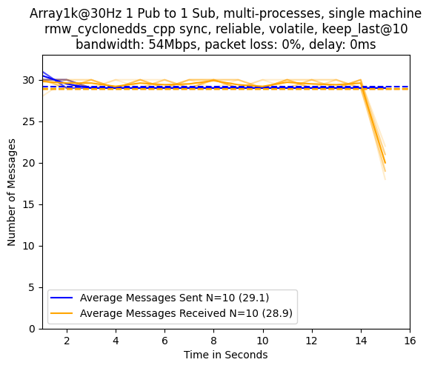

##### Packet Loss: 10%

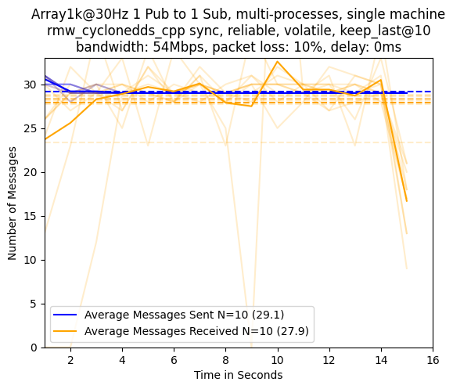

##### Packet Loss: 20%

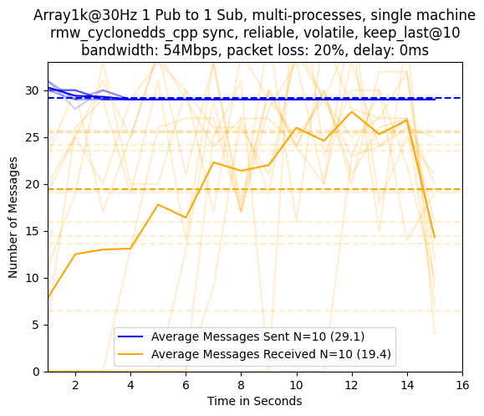

##### Packet Loss: 30%

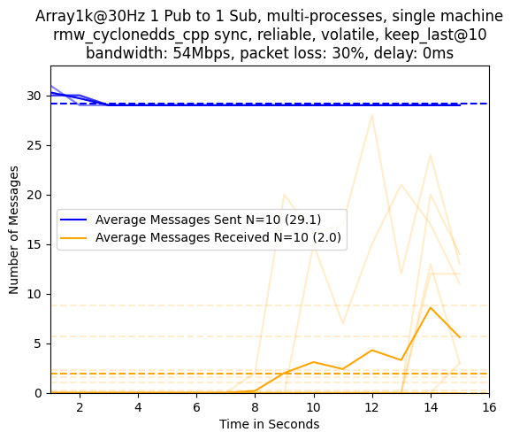

##### Packet Loss: 40%

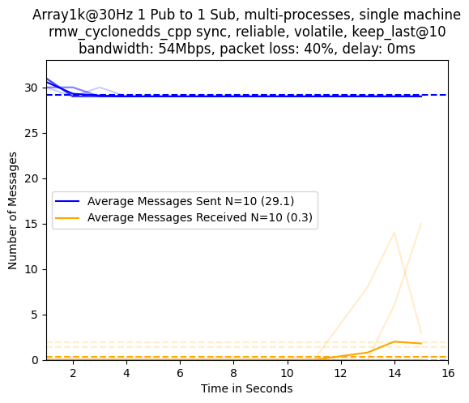

#### rmw_fastrtps_cpp async

##### Packet Loss: 0%

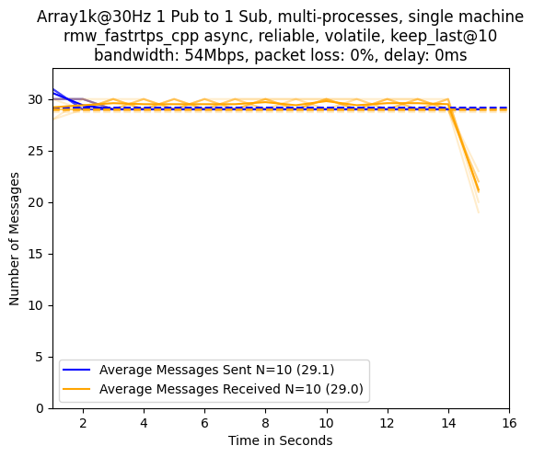

##### Packet Loss: 10%

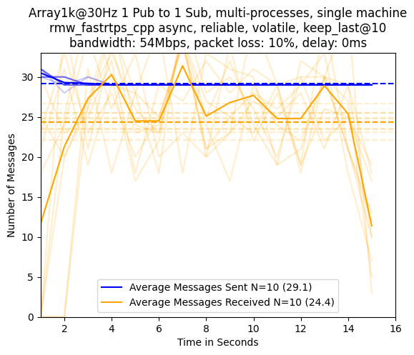

##### Packet Loss: 20%

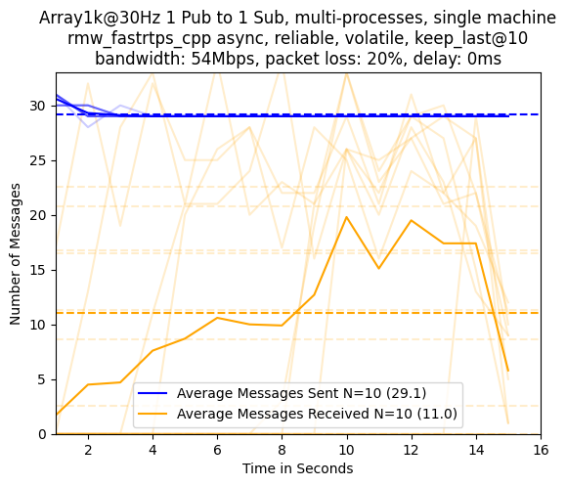

##### Packet Loss: 30%

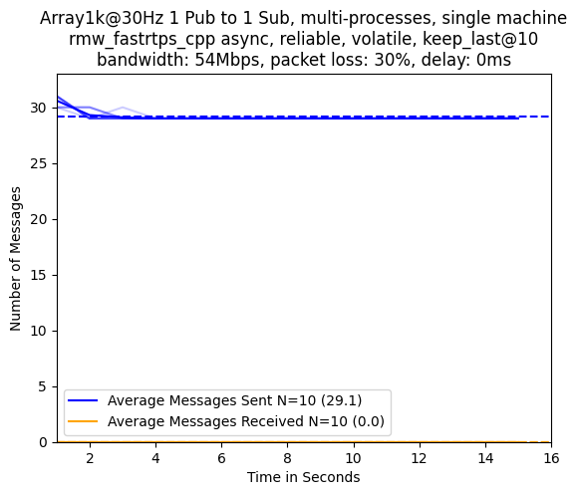

##### Packet Loss: 40%

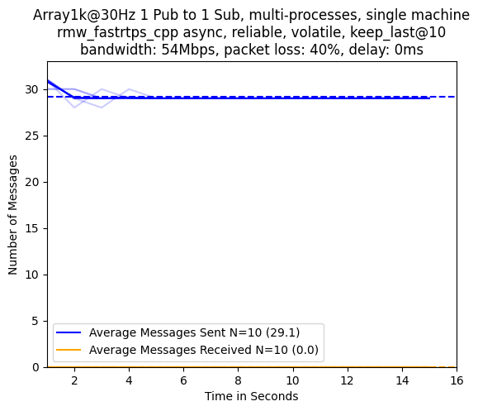

#### rmw_fastrtps_cpp sync

##### Packet Loss: 0%

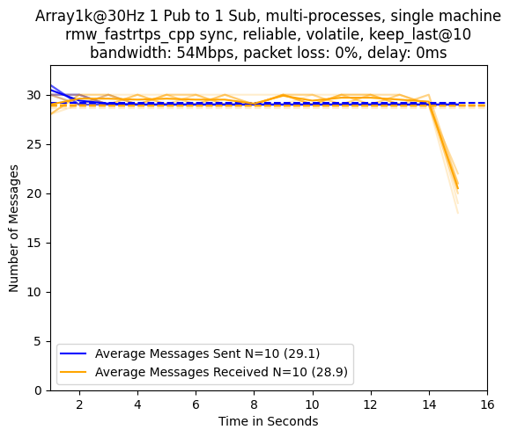

##### Packet Loss: 10%

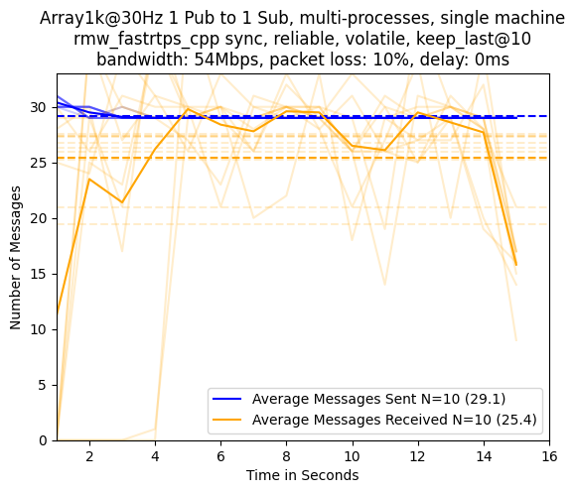

##### Packet Loss: 20%

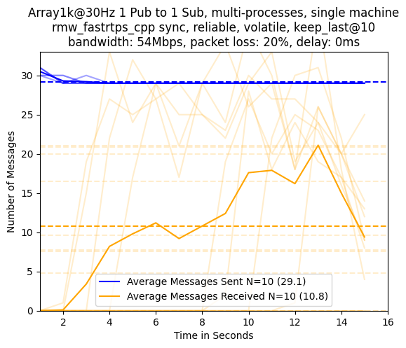

##### Packet Loss: 30%

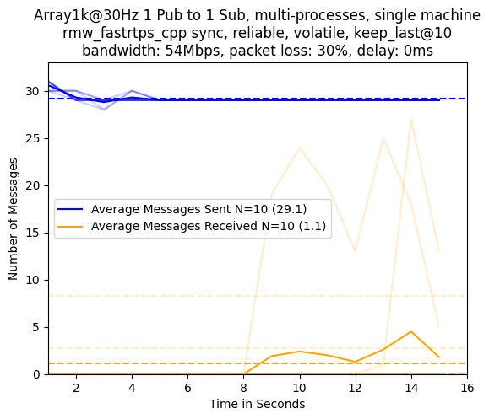

##### Packet Loss: 40%

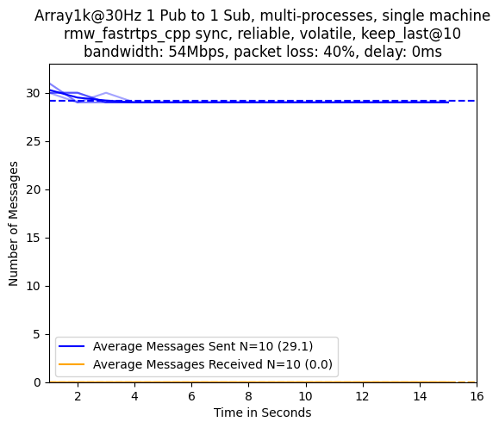

### Comparison Publishing PointCloud512k@30

The specific details for this experiment are as follows:

* 1 Publisher
* 1 Subscription
* Separate Processes
* Single Machine
* Number of Runs Averaged: 10
* RMW Implementation: rmw_cyclonedds_cpp sync/rmw_fastrtps_cpp async/rmw_fastrtps_cpp sync
* Message Type: PointCloud512k
* Message Rate: 30
* Reliability QoS: reliable
* Durability QoS: volatile
* History Kind QoS: keep_last
* History Depth QoS: 10
* Bandwidth Limit (Mbps): 54
* Packet Loss Percentage: 0/10/20/30/40
* Packet Delay (ms): 0

#### rmw_cyclonedds_cpp sync

##### Packet Loss: 0%

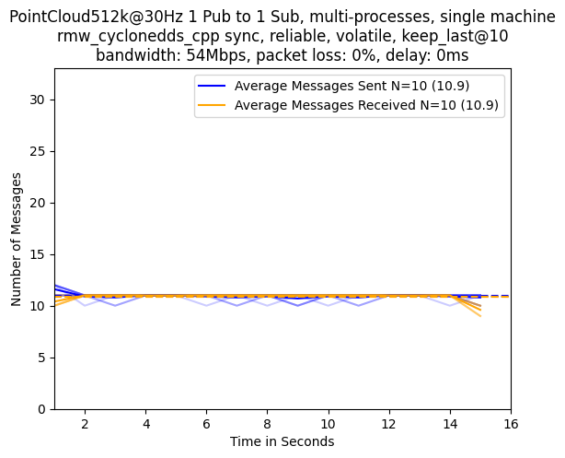

##### Packet Loss: 10%

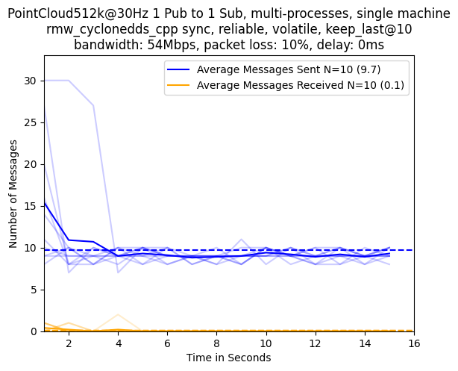

##### Packet Loss: 20%

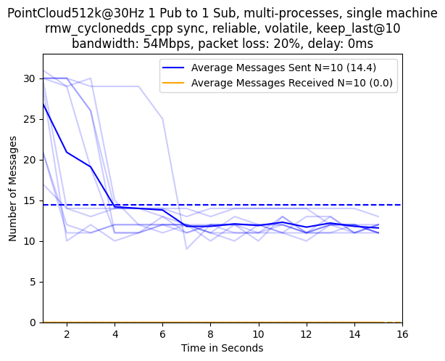

##### Packet Loss: 30%

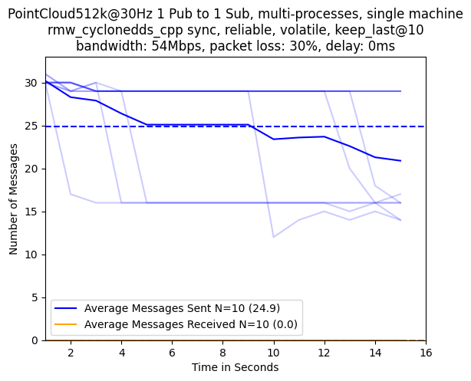

##### Packet Loss: 40%

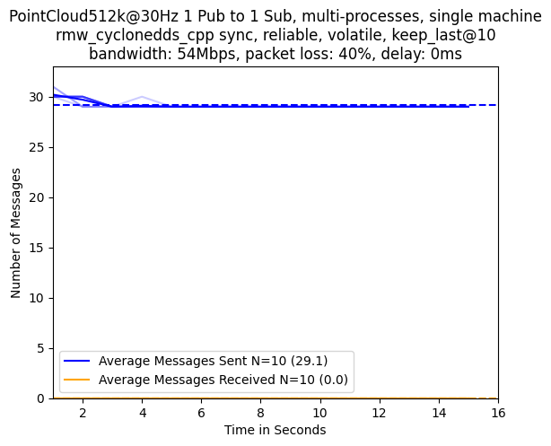

#### rmw_fastrtps_cpp async

##### Packet Loss: 0%

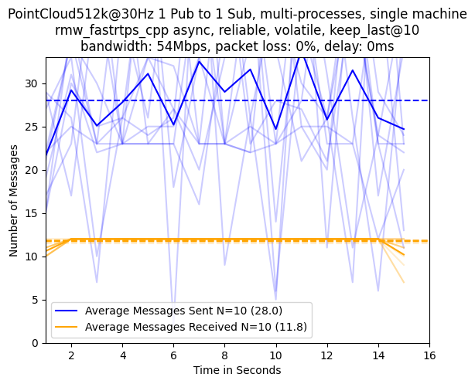

##### Packet Loss: 10%

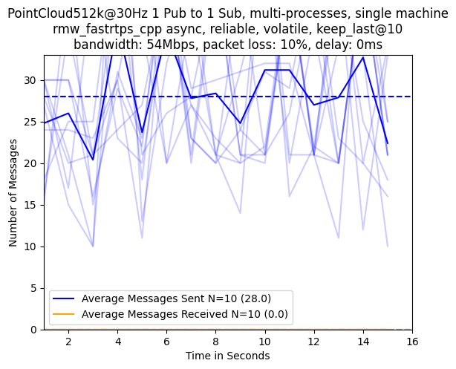

##### Packet Loss: 20%

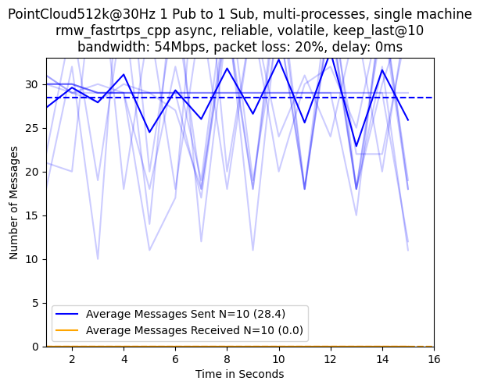

##### Packet Loss: 30%

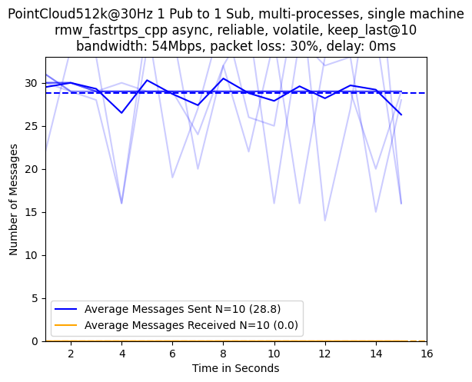

##### Packet Loss: 40%

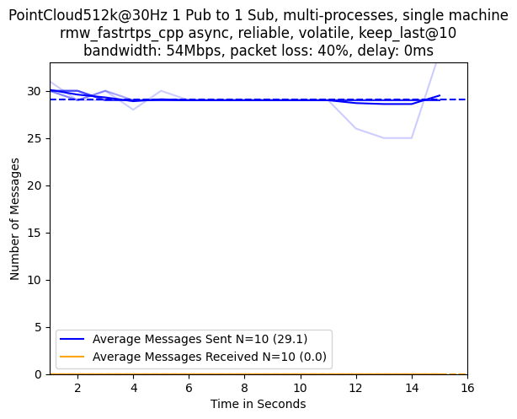

#### rmw_fastrtps_cpp sync

##### Packet Loss: 0%

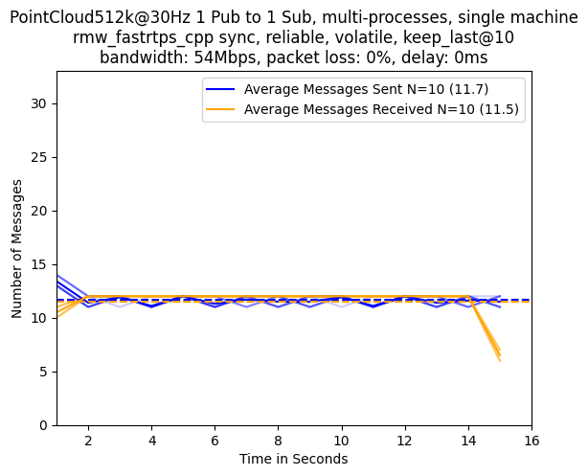

##### Packet Loss: 10%

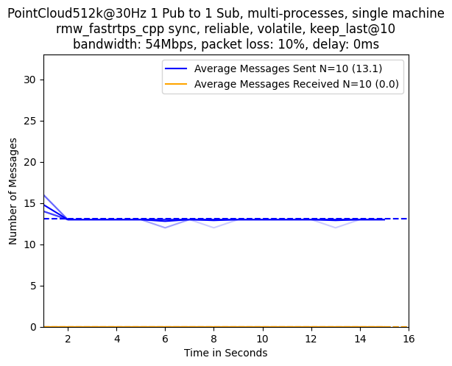

##### Packet Loss: 20%

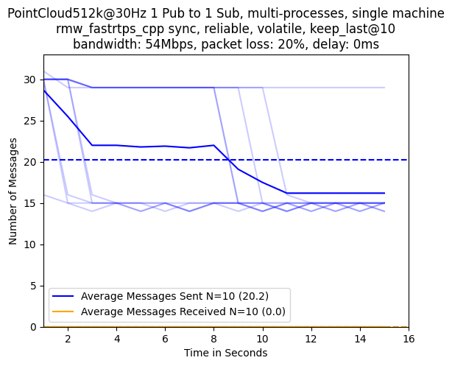

##### Packet Loss: 30%

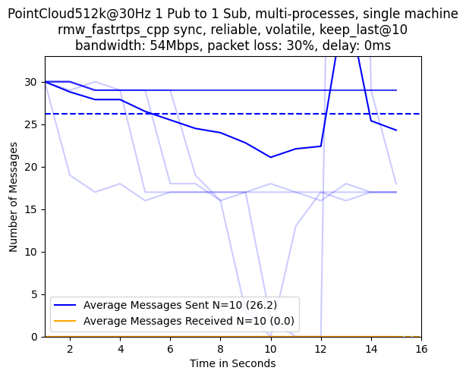

##### Packet Loss: 40%

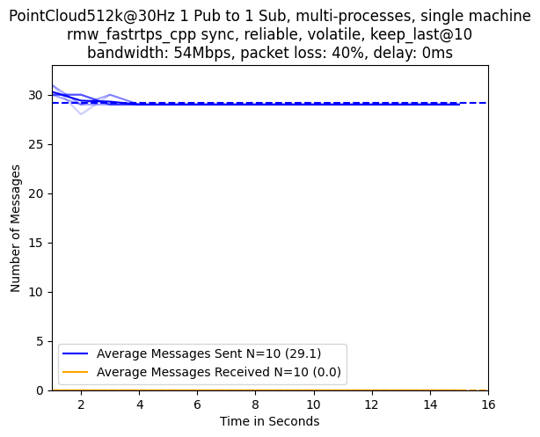

## Comparisons with Bandwidth Limited to 300Mbps

### Comparison Publishing Array1k@30

The specific details for this experiment are as follows:

* 1 Publisher
* 1 Subscription
* Separate Processes
* Single Machine
* Number of Runs Averaged: 10
* RMW Implementation: rmw_cyclonedds_cpp sync/rmw_fastrtps_cpp async/rmw_fastrtps_cpp sync
* Message Type: Array1k
* Message Rate: 30
* Reliability QoS: reliable
* Durability QoS: volatile
* History Kind QoS: keep_last
* History Depth QoS: 10
* Bandwidth Limit (Mbps): 300
* Packet Loss Percentage: 0/10/20/30/40
* Packet Delay (ms): 0

#### rmw_cyclonedds_cpp sync

##### Packet Loss: 0%

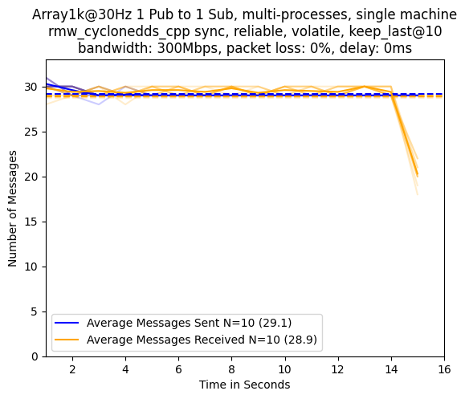

##### Packet Loss: 10%

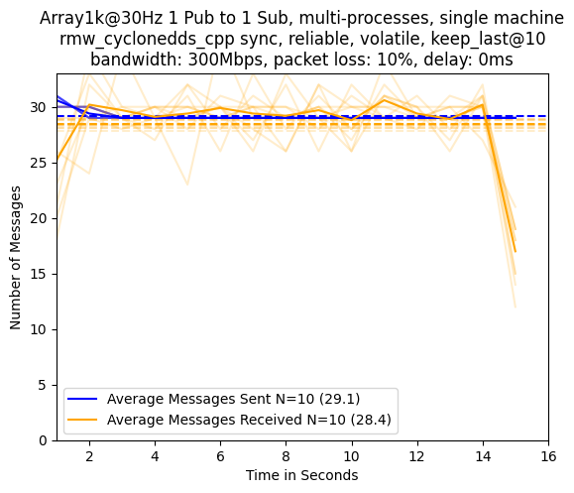

##### Packet Loss: 20%

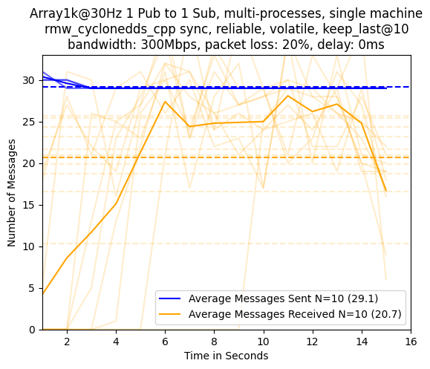

##### Packet Loss: 30%

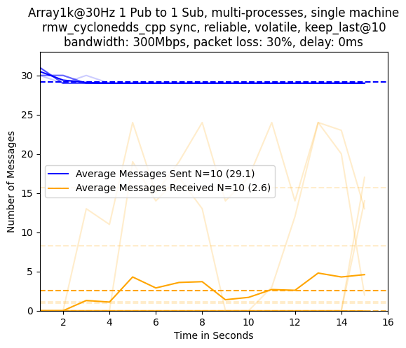

##### Packet Loss: 40%

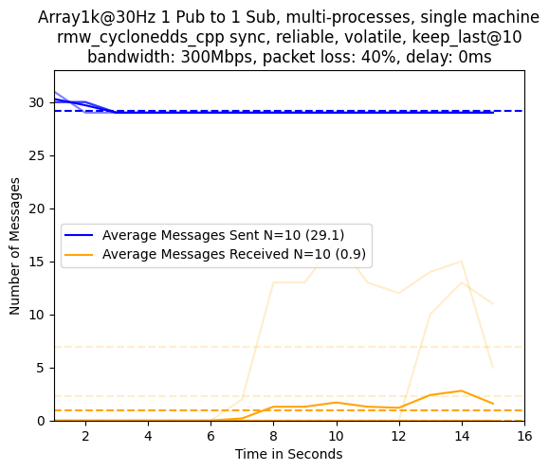

#### rmw_fastrtps_cpp async

##### Packet Loss: 0%

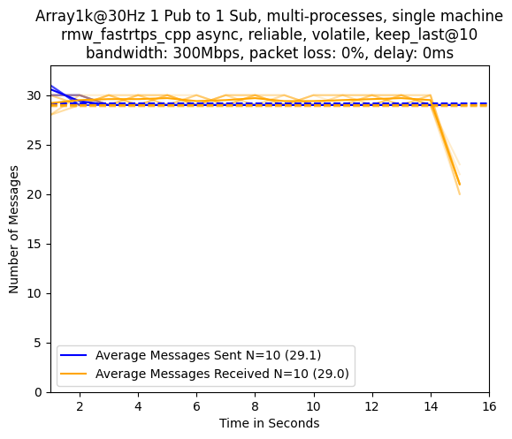

##### Packet Loss: 10%

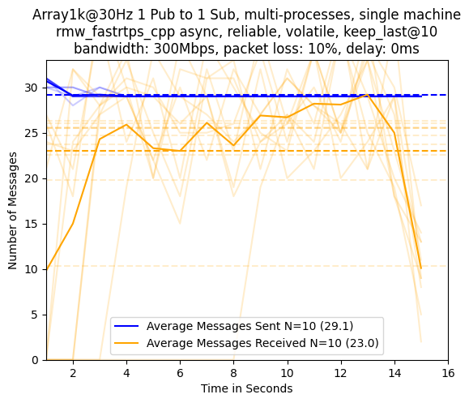

##### Packet Loss: 20%

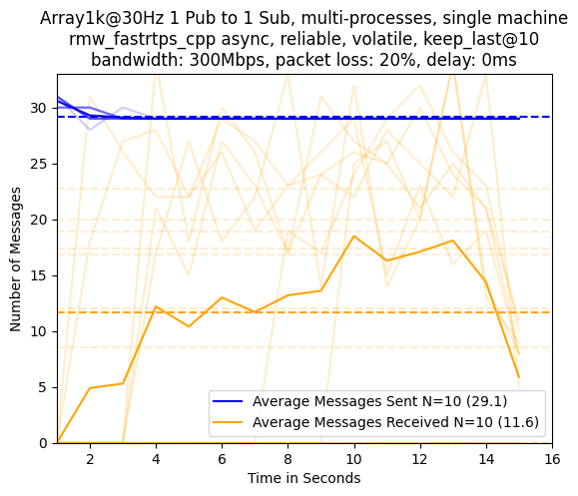

##### Packet Loss: 30%

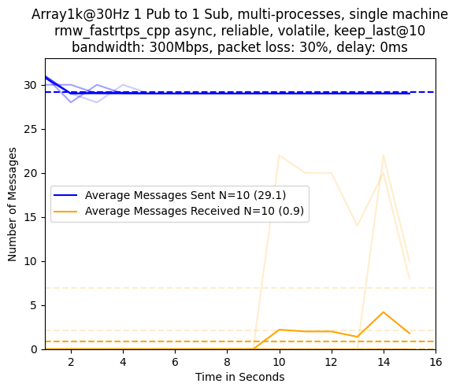

##### Packet Loss: 40%

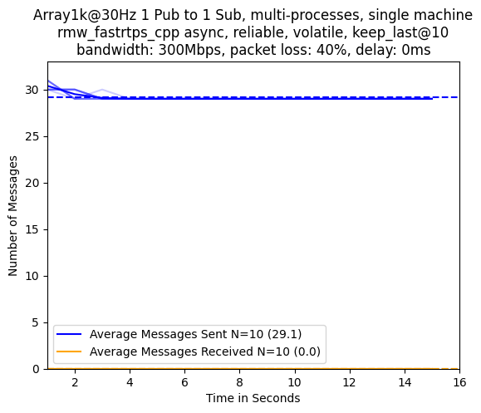

#### rmw_fastrtps_cpp sync

##### Packet Loss: 0%

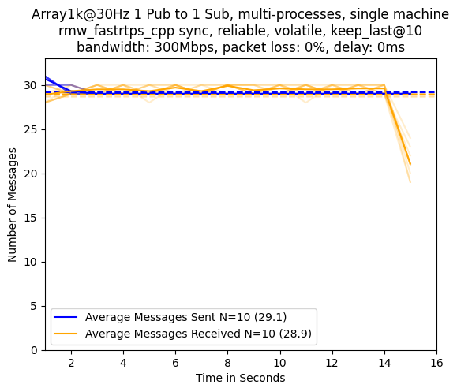

##### Packet Loss: 10%

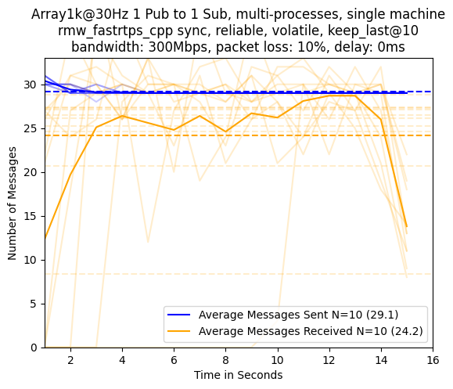

##### Packet Loss: 20%

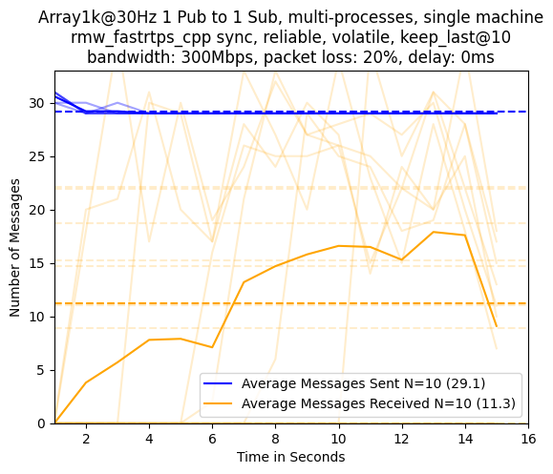

##### Packet Loss: 30%

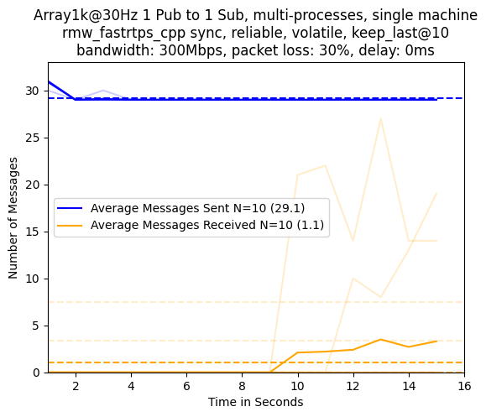

##### Packet Loss: 40%

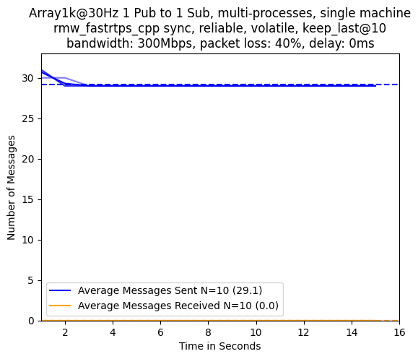

### Comparison Publishing PointCloud512k@30

The specific details for this experiment are as follows:

* 1 Publisher
* 1 Subscription
* Separate Processes
* Single Machine
* Number of Runs Averaged: 10
* RMW Implementation: rmw_cyclonedds_cpp sync/rmw_fastrtps_cpp async/rmw_fastrtps_cpp sync
* Message Type: PointCloud512k
* Message Rate: 30
* Reliability QoS: reliable
* Durability QoS: volatile
* History Kind QoS: keep_last
* History Depth QoS: 10
* Bandwidth Limit (Mbps): 300
* Packet Loss Percentage: 0/10/20/30/40
* Packet Delay (ms): 0

#### rmw_cyclonedds_cpp sync

##### Packet Loss: 0%

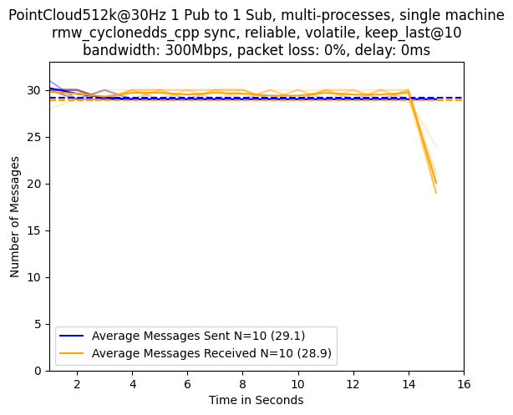

##### Packet Loss: 10%

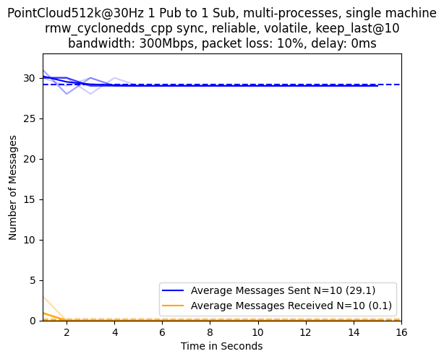

##### Packet Loss: 20%

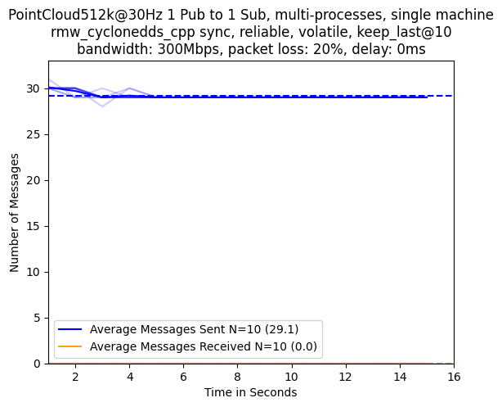

##### Packet Loss: 30%

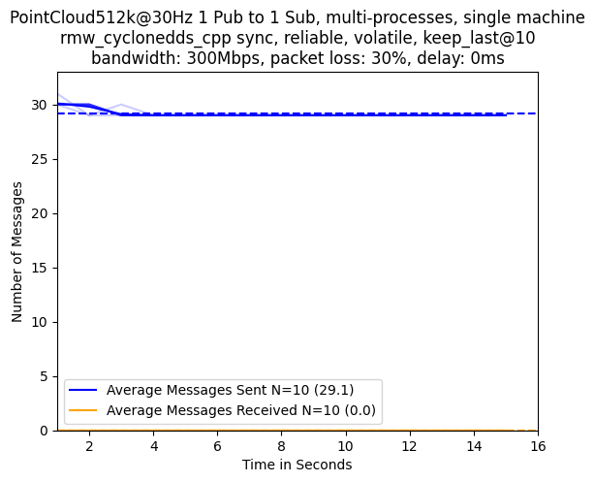

##### Packet Loss: 40%

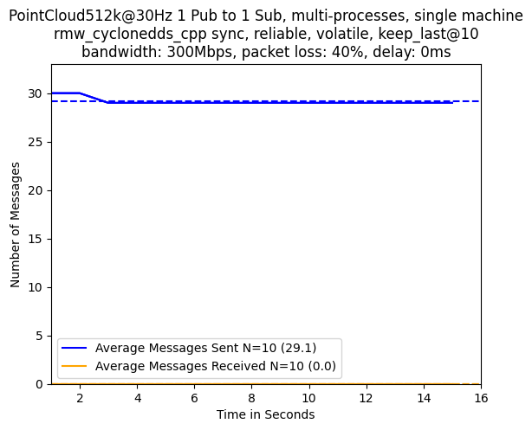

#### rmw_fastrtps_cpp async

##### Packet Loss: 0%

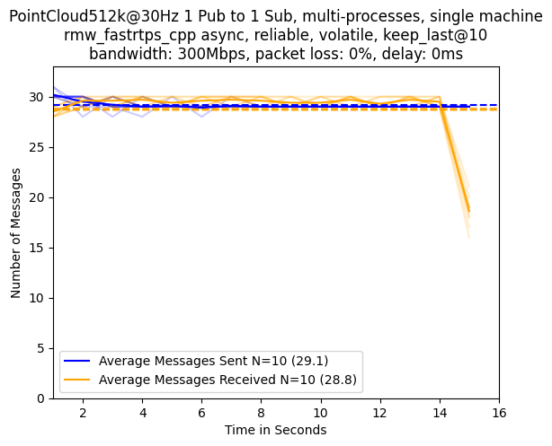

##### Packet Loss: 10%

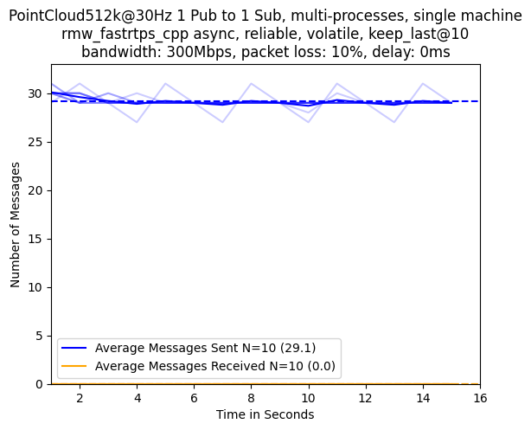

##### Packet Loss: 20%

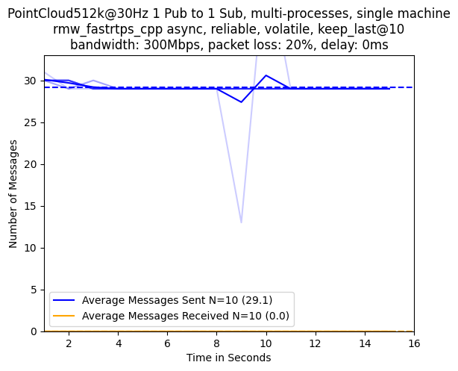

##### Packet Loss: 30%

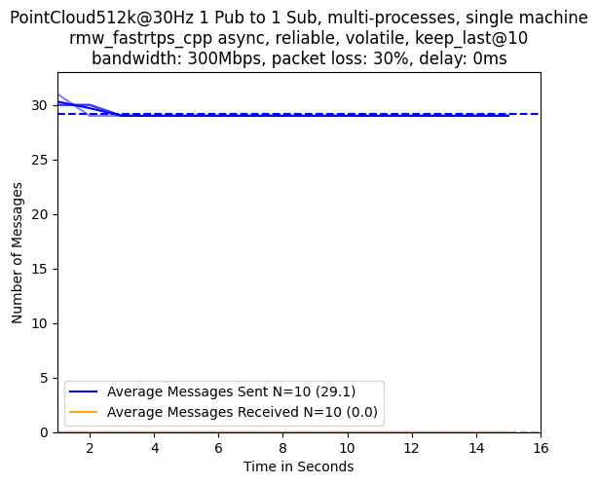

##### Packet Loss: 40%

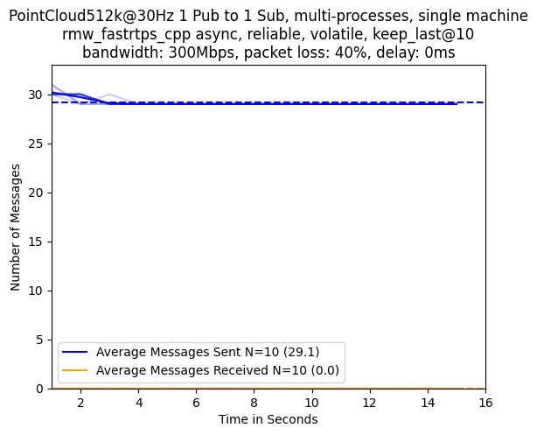

#### rmw_fastrtps_cpp sync

##### Packet Loss: 0%

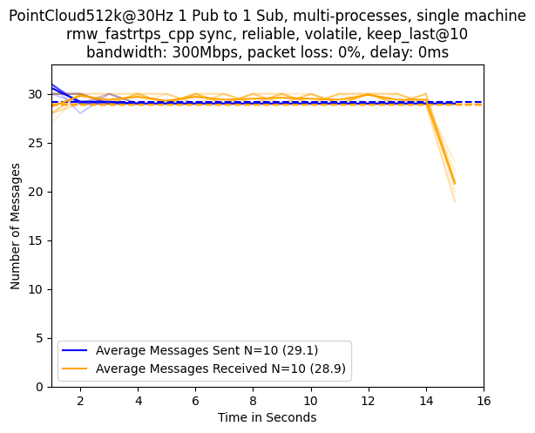

##### Packet Loss: 10%

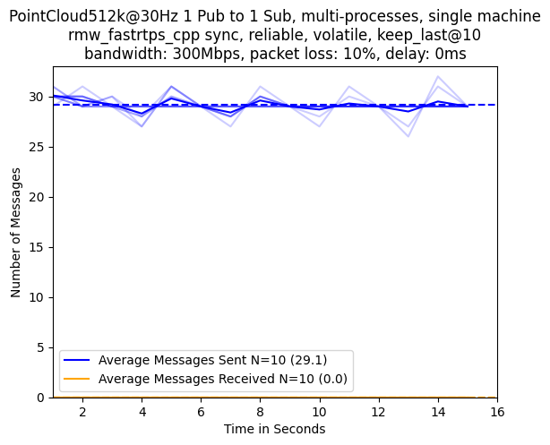

##### Packet Loss: 20%

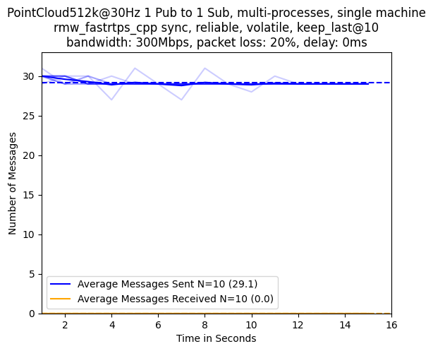

##### Packet Loss: 30%

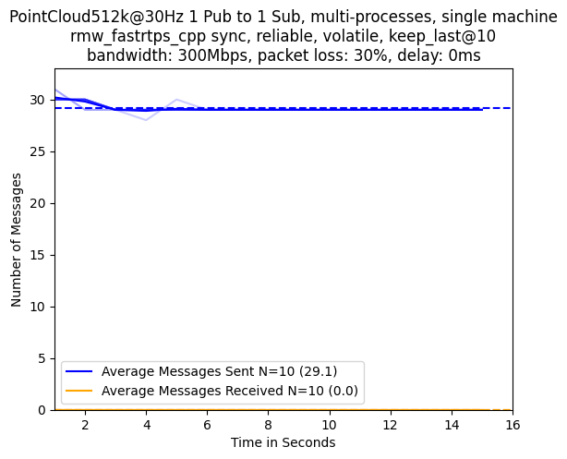

##### Packet Loss: 40%

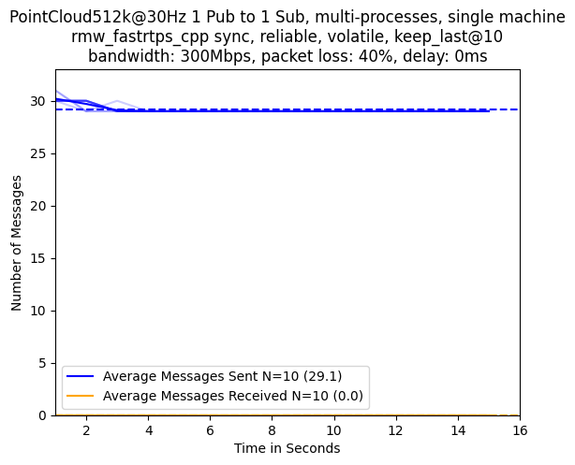

## Comparisons with Bandwidth Limited to 1000Mbps

### Comparison Publishing Array1k@30

The specific details for this experiment are as follows:

* 1 Publisher
* 1 Subscription
* Separate Processes
* Single Machine
* Number of Runs Averaged: 10
* RMW Implementation: rmw_cyclonedds_cpp sync/rmw_fastrtps_cpp async/rmw_fastrtps_cpp sync
* Message Type: Array1k
* Message Rate: 30
* Reliability QoS: reliable
* Durability QoS: volatile
* History Kind QoS: keep_last
* History Depth QoS: 10
* Bandwidth Limit (Mbps): 1000
* Packet Loss Percentage: 0/10/20/30/40
* Packet Delay (ms): 0

#### rmw_cyclonedds_cpp sync

##### Packet Loss: 0%

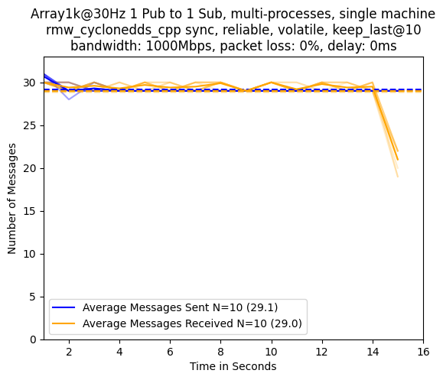

##### Packet Loss: 10%

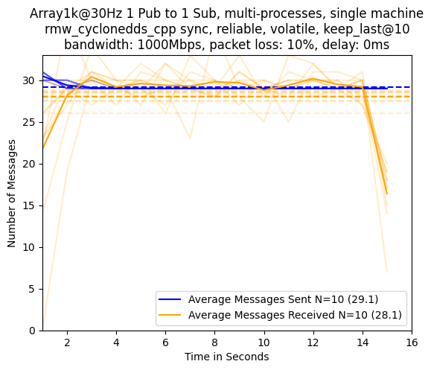

##### Packet Loss: 20%

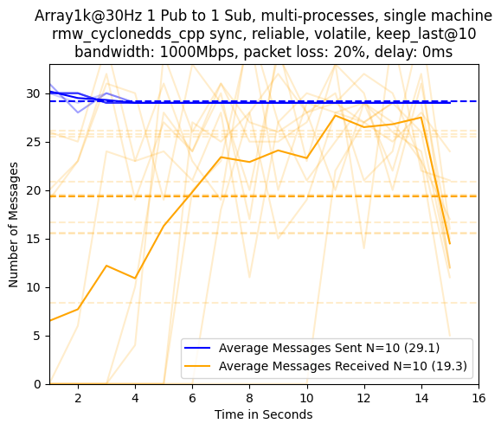

##### Packet Loss: 30%

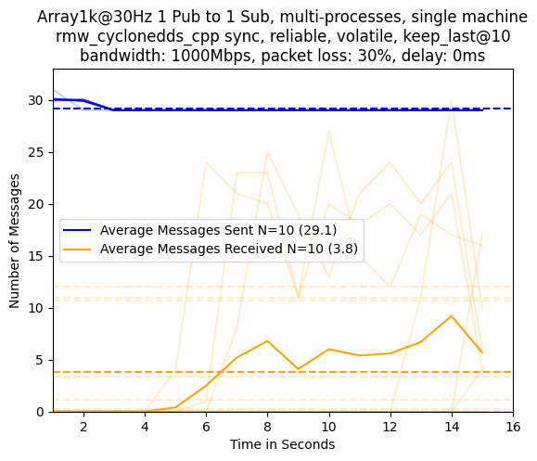

##### Packet Loss: 40%

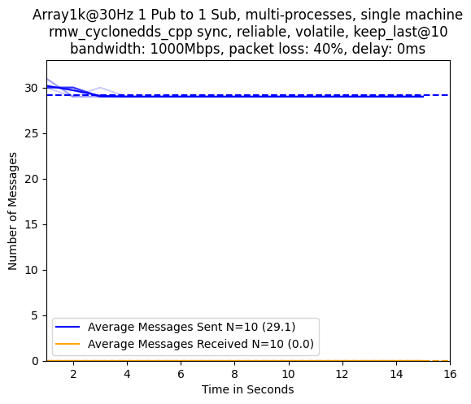

#### rmw_fastrtps_cpp async

##### Packet Loss: 0%

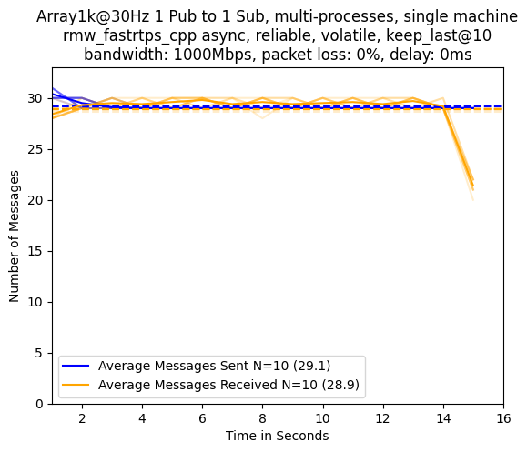

##### Packet Loss: 10%

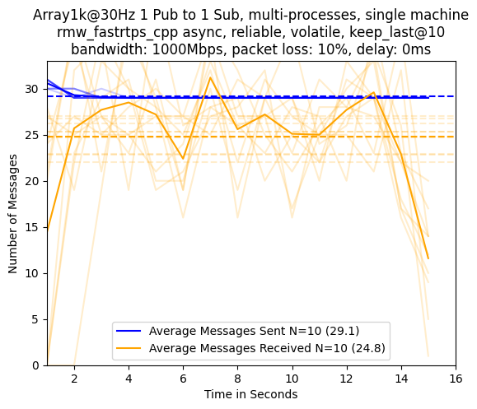

##### Packet Loss: 20%

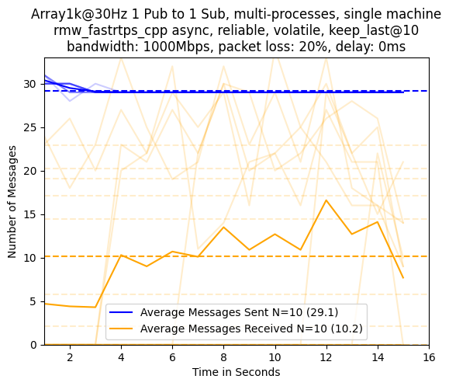

##### Packet Loss: 30%

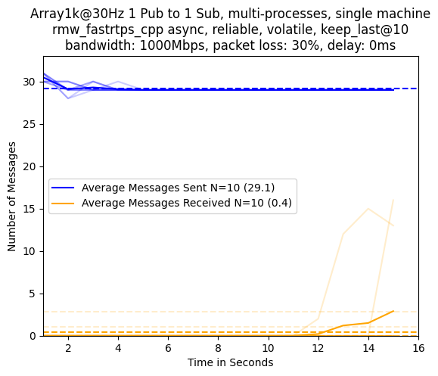

##### Packet Loss: 40%

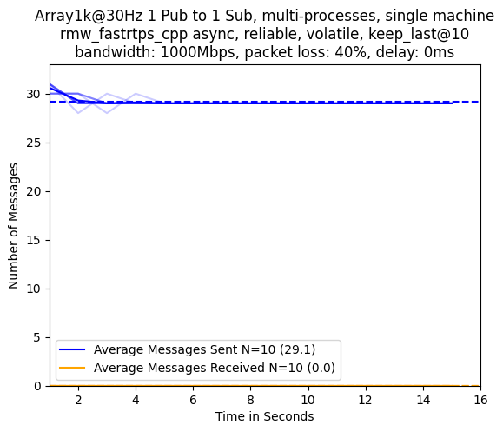

#### rmw_fastrtps_cpp sync

##### Packet Loss: 0%

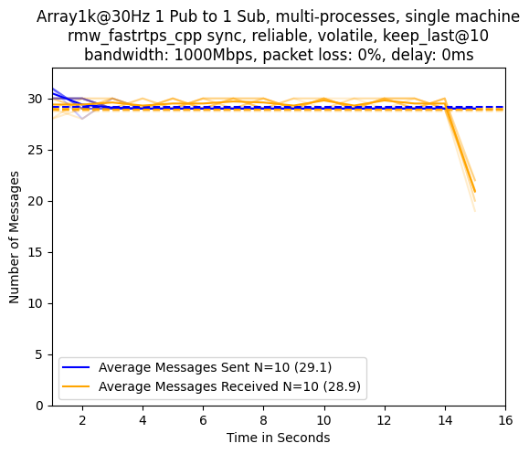

##### Packet Loss: 10%

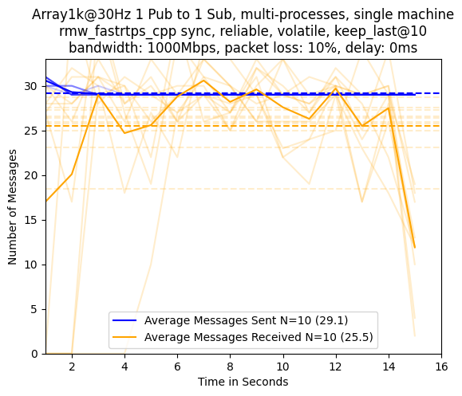

##### Packet Loss: 20%

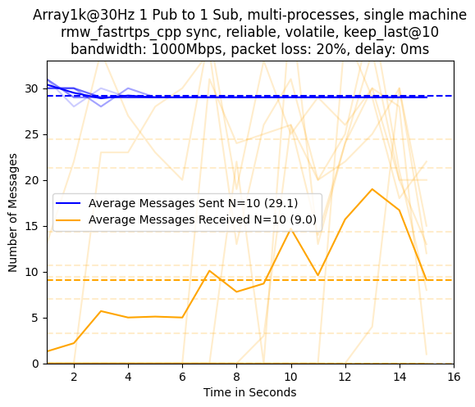

##### Packet Loss: 30%

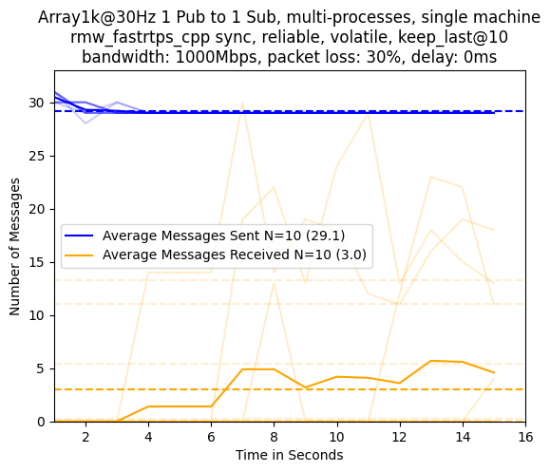

##### Packet Loss: 40%

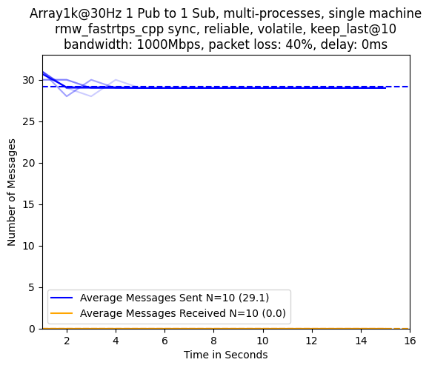

### Comparison Publishing PointCloud512k@30

The specific details for this experiment are as follows:

* 1 Publisher
* 1 Subscription
* Separate Processes
* Single Machine
* Number of Runs Averaged: 10
* RMW Implementation: rmw_cyclonedds_cpp sync/rmw_fastrtps_cpp async/rmw_fastrtps_cpp sync
* Message Type: PointCloud512k
* Message Rate: 30
* Reliability QoS: reliable
* Durability QoS: volatile
* History Kind QoS: keep_last
* History Depth QoS: 10
* Bandwidth Limit (Mbps): 1000
* Packet Loss Percentage: 0/10/20/30/40
* Packet Delay (ms): 0

#### rmw_cyclonedds_cpp sync

##### Packet Loss: 0%

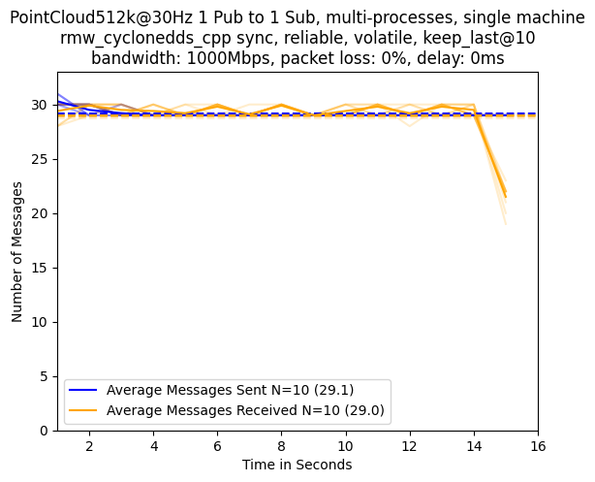

##### Packet Loss: 10%

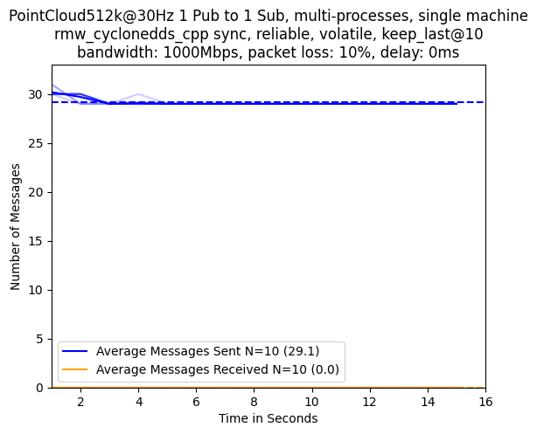

##### Packet Loss: 20%

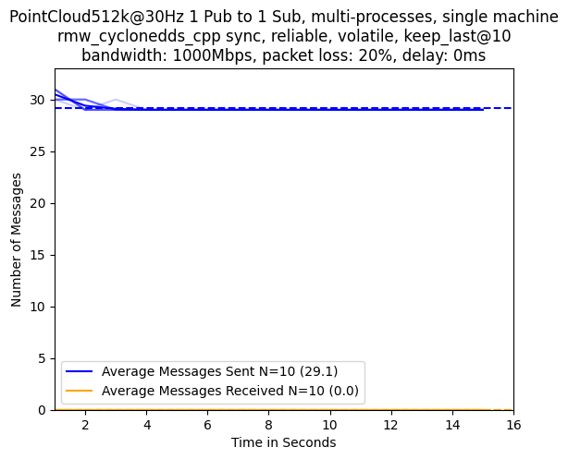

##### Packet Loss: 30%

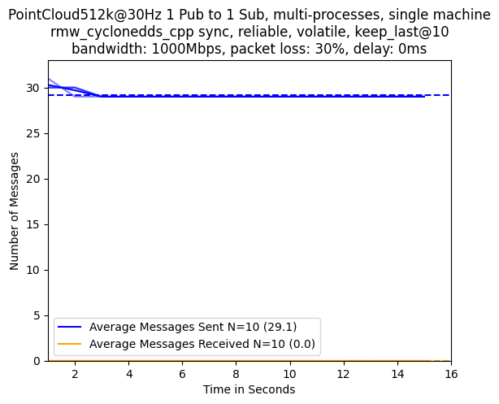

##### Packet Loss: 40%

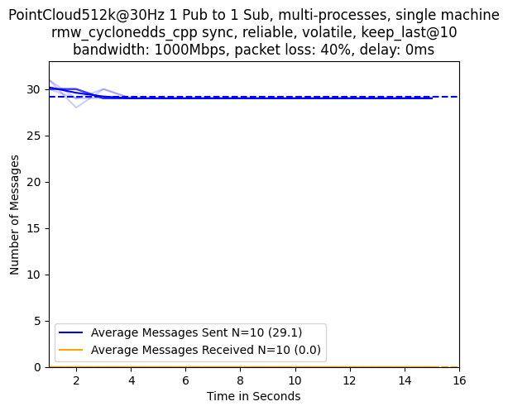

#### rmw_fastrtps_cpp async

##### Packet Loss: 0%

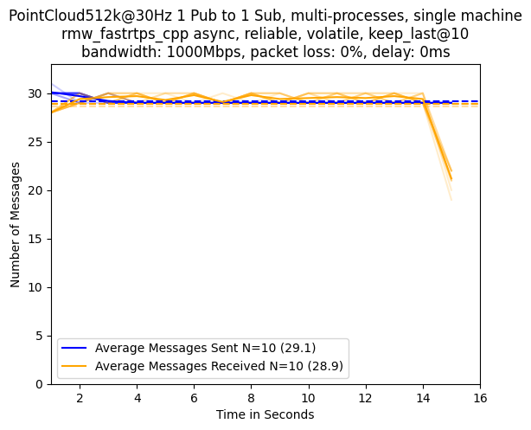

##### Packet Loss: 10%

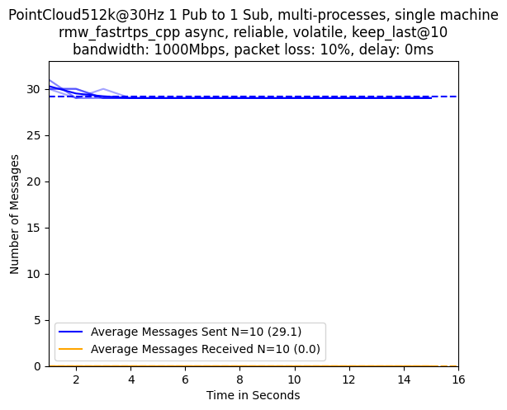

##### Packet Loss: 20%

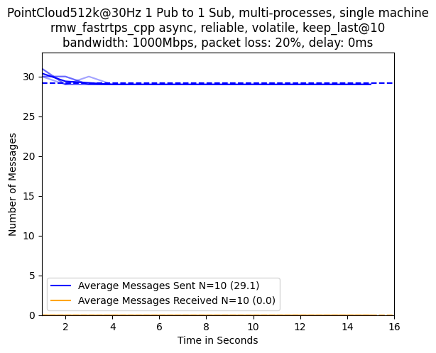

##### Packet Loss: 30%

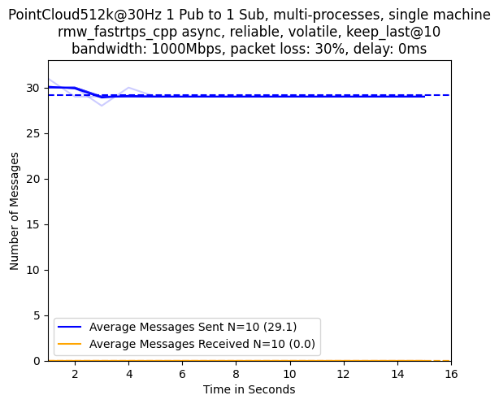

##### Packet Loss: 40%

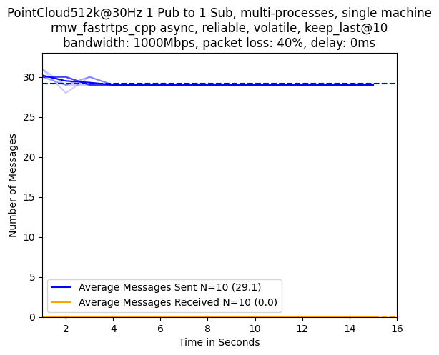

#### rmw_fastrtps_cpp sync

##### Packet Loss: 0%

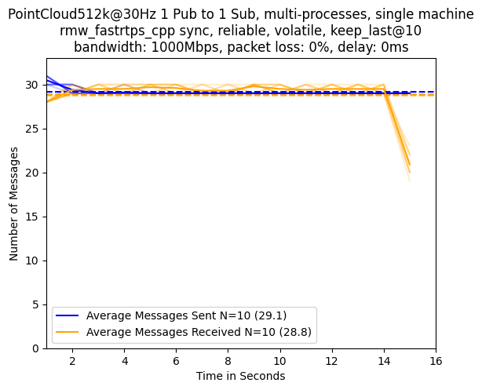

##### Packet Loss: 10%

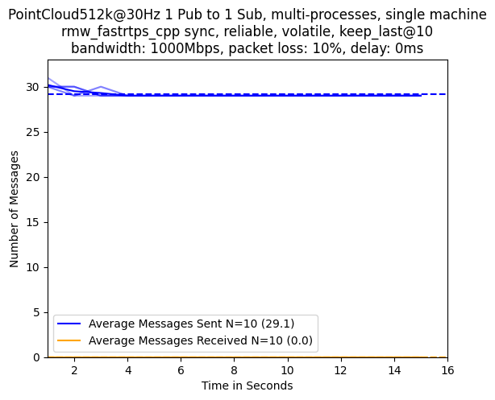

##### Packet Loss: 20%

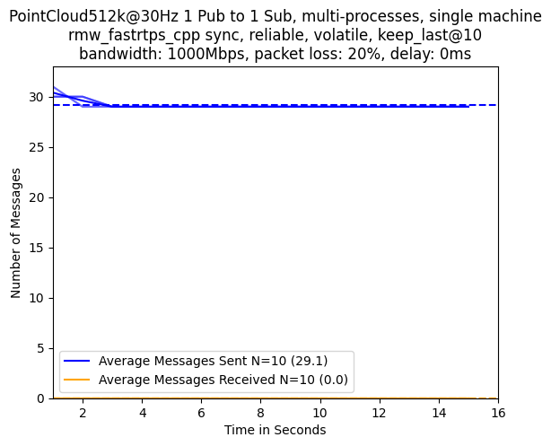

##### Packet Loss: 30%

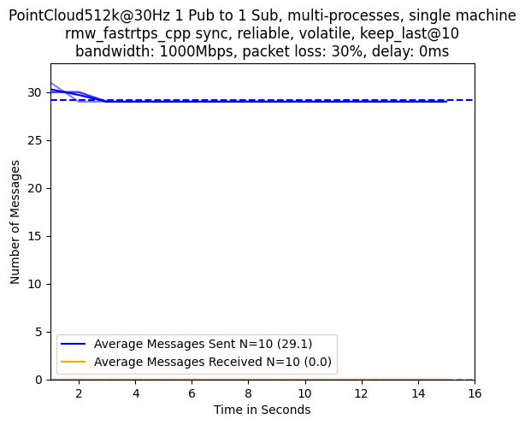

##### Packet Loss: 40%

